Hotel Reservation Form
KEA-APEA 2017 Conference

* Please complete and return this form to Hotel Koreana
by fax or email no later than June 20, 2017
(Fax : +82-2-730-9025 / E-mail : don@koreanahotel.com)
Personal Information * Please fill in the blank below, required items: marked ‘*’
*Name: |  |  |  |  | Grade:
*Nationality |  |  |  |  | Phone:
*Email:
*Arrival Date:  (Check In) |  |  |  |  | *Depart Date:  (Check Out)
*Credit Card No.
*CC Number: |  |  |  |  | *CC Expiration:
Room Type * Please fill in the blank below
The above rates are included 10% tax and 10% service charge.(Include Breakfast)
Rm. Type |  | Double | Unit (1Person) |  |  | Twin |  | Unit (2Persons)
Business Queen |  | 115,000 KRW |  |  |  | 135,000 KRW
Executive Queen |  | 145,000 KRW |  |  |  | 165,000 KRW
Requirements(Non-smoking, etc)

* The price includes the TV, Internet, and use of the fitness center at 23F, VAT & TAX (Included)
* Each guest need to pay the hotel rates on check-out date
* Guest has no responsibility on any reservation problem, payment, refund policy, cancel charge, etc. please contact with the reservation manager from Hotel Koreana if you have any problem on the reservation
* But, remember you can reserve the hotel rooms through this reservation form organized by KEA that it can benefits you with discounted price rates
* Early check in charge KRW 60,000++ (am 6:00 ~ pm12:00)
* Extra Bed(KRW 60,000)

Cancellation & No show Policy
D-Day | Cancel Charge |  |  | Remark
Check-in Date | 100% |  |  | * Same policy on No show(without notice)
1day before | 50%
*KAL LIMOUSINE BUS (No. 6701, CITY HALL AREA)
KAL Limousine bus runs every 20minute from INCHEON ITN’L AIRPORT(via GIMPO ITN’L AIRPORT) to KOREANA Hotel (05:50~22:30). Bus stop is right in front of our hotel. Tickets are sold at the airport terminal, our hotel and all KAL Ticket counters in Seoul.
For more details, please visit our website www. Koreanahotel.com

SALES REPRESENTATIVE: Donald Oh (Oh, Dong-Hee)
MOBILE: +82 (0)10-5302-4210
ADD: 61 1-GA TAEPYUNG-RO CHUNG-GU SEOUL
TEL: +82-2-2171-7000(Rep.) +82-2-2171-7845(Reservation office)
FAX: +82-2-734-0665(Service center) +82-2-730-9025(Reservation office)

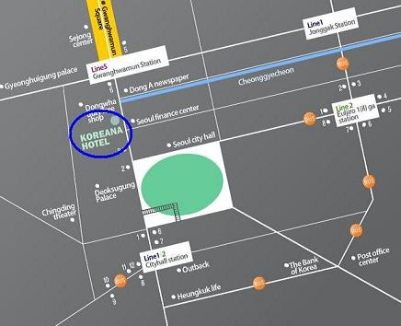

Koreana Hotel  Rep. Tel: 02-2171-7000 Fax: 02-734-0665 |  |  |  | Sales Rep. Donald Oh  Mobile: 010-5302-4210 Tel:02-2171-7912
General | Classification: ★★★★☆  ■ Room  ▶ Business type room  • Business queen(32) • Business twin-A(89) • Business twin-B(16)  ▶ Executive type room  • Executive queen(31) • Executive twin(17) • Executive king(21)  ▶ Suite room  • Royal suite(2) • Imperial suite(1)
Breakfast | Location | - Lobby Floor 2F; Danube |  |  | Hours | - 06.30 – 10.00
 | Menu | - Buffet
Transportation | Hotel Incheon Airport |  | KAL Limousine 6701: 04.50 ~ 22.25(every 20minute)
 | Hotel Kimpo Airport |  | Service#: 601, 6001<To SEOUL city hall>
Facilities
Swimming pool | Sauna |  |  | Fitness |  | Tennis Court |  | Free breakfast
Exchange | Kiosk |  |  | EFL Lounge |  | Business Center |  | Free Laundry
Other | - BAR, Business center, Gift shop: 2nd FL  - Fitness: 23rd FL  - Sauna: 8th FL  - EFL Lounge: Only for executive room type guest  - Free EFL Meeting room: Only for executive room type guest (2 hours)  - Free Laundry: Only for executive room type guest  - Free breakfast: Only for executive room type guest
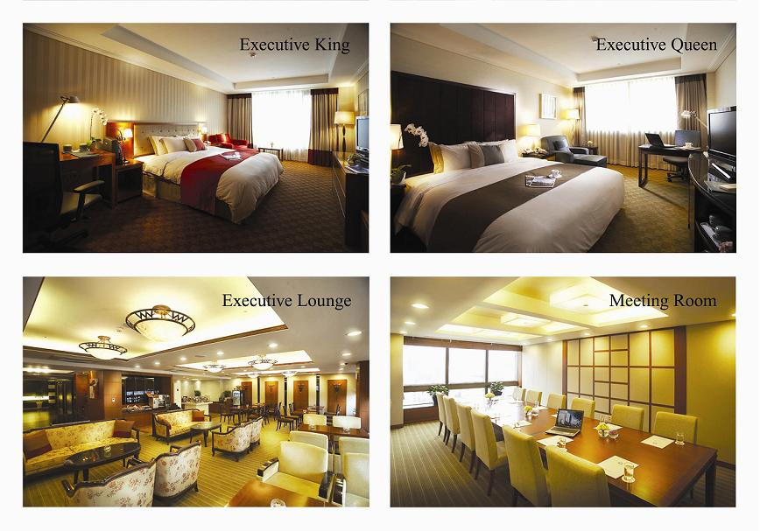 |  |  | Free water |  | Iron |  | Fridge |  | Coffee maker
 |  |  | Kitchen stuff |  | Window open |  | Hot Pot |  | Mini Bar
 |  |  | Hair Dryer |  | Bath |  | Microwave |  | Desk
 |  |  | TV channel
 |  |  | 23 SBS  24 KBS1  25 KBS2  26 MBC  27A.FKOREA  29 XPORTS  35 BS NHK  43CHANNEL-V |  | 45 TV5(France)  51 CNN  53 HAO TV  54 CGV  55 OCN  56 YTN  57 SBS Sports  59 MBC ESPN |  | 64 NHK 65 STAR SPORTS  69 MTV 70 discovery
 |  |  |  |  |  |  | Adapter
220V
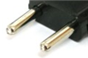
Internet |  | Wireless internet  Contracted organization: Free
When making a request, we provide at free following below;
• Microwave • Humidifier • Baby cot • Newspaper • Extra blanket
Executive Club Floor 17,18 fl. And 21 fl.
1. Executive Lounge 21 fl. (Breakfast 07:00~10:00/ Coffee& tea 10:00~17:30/ Happy hour 18:00~ 20:30)
2. Amenity: Room - LCD TV, Hi speed internet free, Mineral water 2 bottles
3. Lounge: Meeting room (Capacity 12 person) free 2 hours, Internet Access

